**Selenium IDE (Integrated Development Environment)** is the simplest tool in the Selenium Suite. Tell about actual usage of selenium IDE to identify iframes

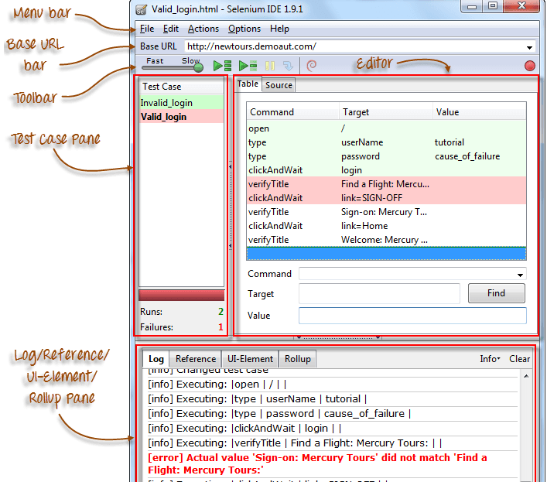

**Selenium Grid** is a part of the Selenium Suite that specializes in running multiple tests across different browsers, operating systems, and machines in parallel.

When to use selenium grid :

* **Run your tests against different browsers, operating systems, and machines all at the same time.**This will ensure that the application you are[Testing](https://www.guru99.com/software-testing.html)is fully compatible with a wide range of browser-O.S combinations.
* **Save time in the execution of your test suites**. If you set up Selenium Grid to run, say, 4 tests at a time, then you would be able to finish the whole suite around 4 times faster.
* 